Presentation title in sentence case (bold)
John A Smith¹, Jack N Smith^{1,2}. Department Name, Organisation¹, City, STATE, Country; Department Name, Organisation², City, STATE, Country. (please abbreviate state)
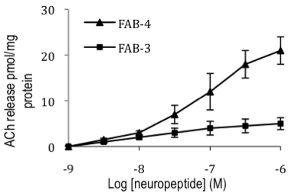
Introduction. Text to begin immediately following the heading and without additional line spacing. Do not bold or underline heading.
Aims. Text to begin immediately following the heading and without additional line spacing. Do not bold or underline heading.
Methods. Text to begin immediately following the heading and without additional line spacing. Do not bold or underline heading.
Results. Text to begin immediately following the heading and without additional line spacing. Do not bold or underline heading.
Discussion. Text to begin immediately following the heading and without additional line spacing. Do not bold or underline heading.

Do not change the margins, the font, size or any other setup on this template. The abstract should be left-and right-justified. Line spacing must be single. The abstract must be one A5 page only. The abstract must be typed in Calibri 10 point. Do not use bold in the abstract text, only the title should be in bold. As abstract pages may be printed in black and white only, you may consider including tables and images in greyscale. Please pay particular attention to these instructions as abstracts that do not conform will not be accepted by the editors.

The text should be as informative as possible. If you have any problems please call Expert Events on +61 7 3848 2100 or wcp2026@expertevents.com.au.

McCartney P (2001) J J 56:23-33
Starr R et al (2005) Pharmacology of FAB-4, ed Ono Y. pp 12-23, Tokyo, Abbey Road Press

